Missing at Random (MAR) Analysis Report
Generated on: 2026-04-28 08:44:43
Dataset: 336,097 rows × 18 columns

1. Executive Summary
• Total missing values: 33,826 (0.56% of all data)
• Variables with missing data: 3 out of 18
• MAR supported for: 2 variables

2. Dataset Overview
Metric | Value
Number of Rows | 336,097
Number of Columns | 18
Total Missing Values | 33,826
Overall Missing Rate | 0.56%

3. Missing Data Summary
Variable | Data Type | Missing Count | Missing %
Birth_Weight(grams) | float64 | 33,604 | 10.00%
Race_of_Father | str | 221 | 0.07%
Birth_Order | str | 1 | 0.00%

4. Missing at Random (MAR) Analysis Results

4.1 Variable: Birth_Weight(grams)
Missing Statistics:
• Missing values: 33,604 (10.00%)
• Data type: float64
MAR Determination: YES - Missing at Random supported
Missingness in "Birth_Weight(grams)" is significantly associated with 3 other observed variable(s) in the dataset, satisfying the MAR condition.
- Associated Variables:
Associated Variable | Type | Statistical Test | P-value
Birh_Year | numerical | Mann-Whitney U | 0.0000
Birth_Year_2.0 | numerical | Mann-Whitney U | 0.0000
TWIN | numerical | Mann-Whitney U | 0.0000

4.2 Variable: Birth_Order
Missing Statistics:
• Missing values: 1 (0.00%)
• Data type: str
MAR Determination: NO - No MAR evidence found
No statistically significant associations were found between missingness in "Birth_Order" and other observed variables. This pattern suggests either Missing Completely at Random (MCAR) or Missing Not at Random (MNAR).

4.3 Variable: Race_of_Father
Missing Statistics:
• Missing values: 221 (0.07%)
• Data type: str
MAR Determination: YES - Missing at Random supported
Missingness in "Race_of_Father" is significantly associated with 3 other observed variable(s) in the dataset, satisfying the MAR condition.
- Associated Variables:
Associated Variable | Type | Statistical Test | P-value
Birh_Year | numerical | Mann-Whitney U | 0.0000
Birth_Year_2.0 | numerical | Mann-Whitney U | 0.0000
Age of Mother | numerical | Mann-Whitney U | 0.0062

5. Missing Data Visualizations
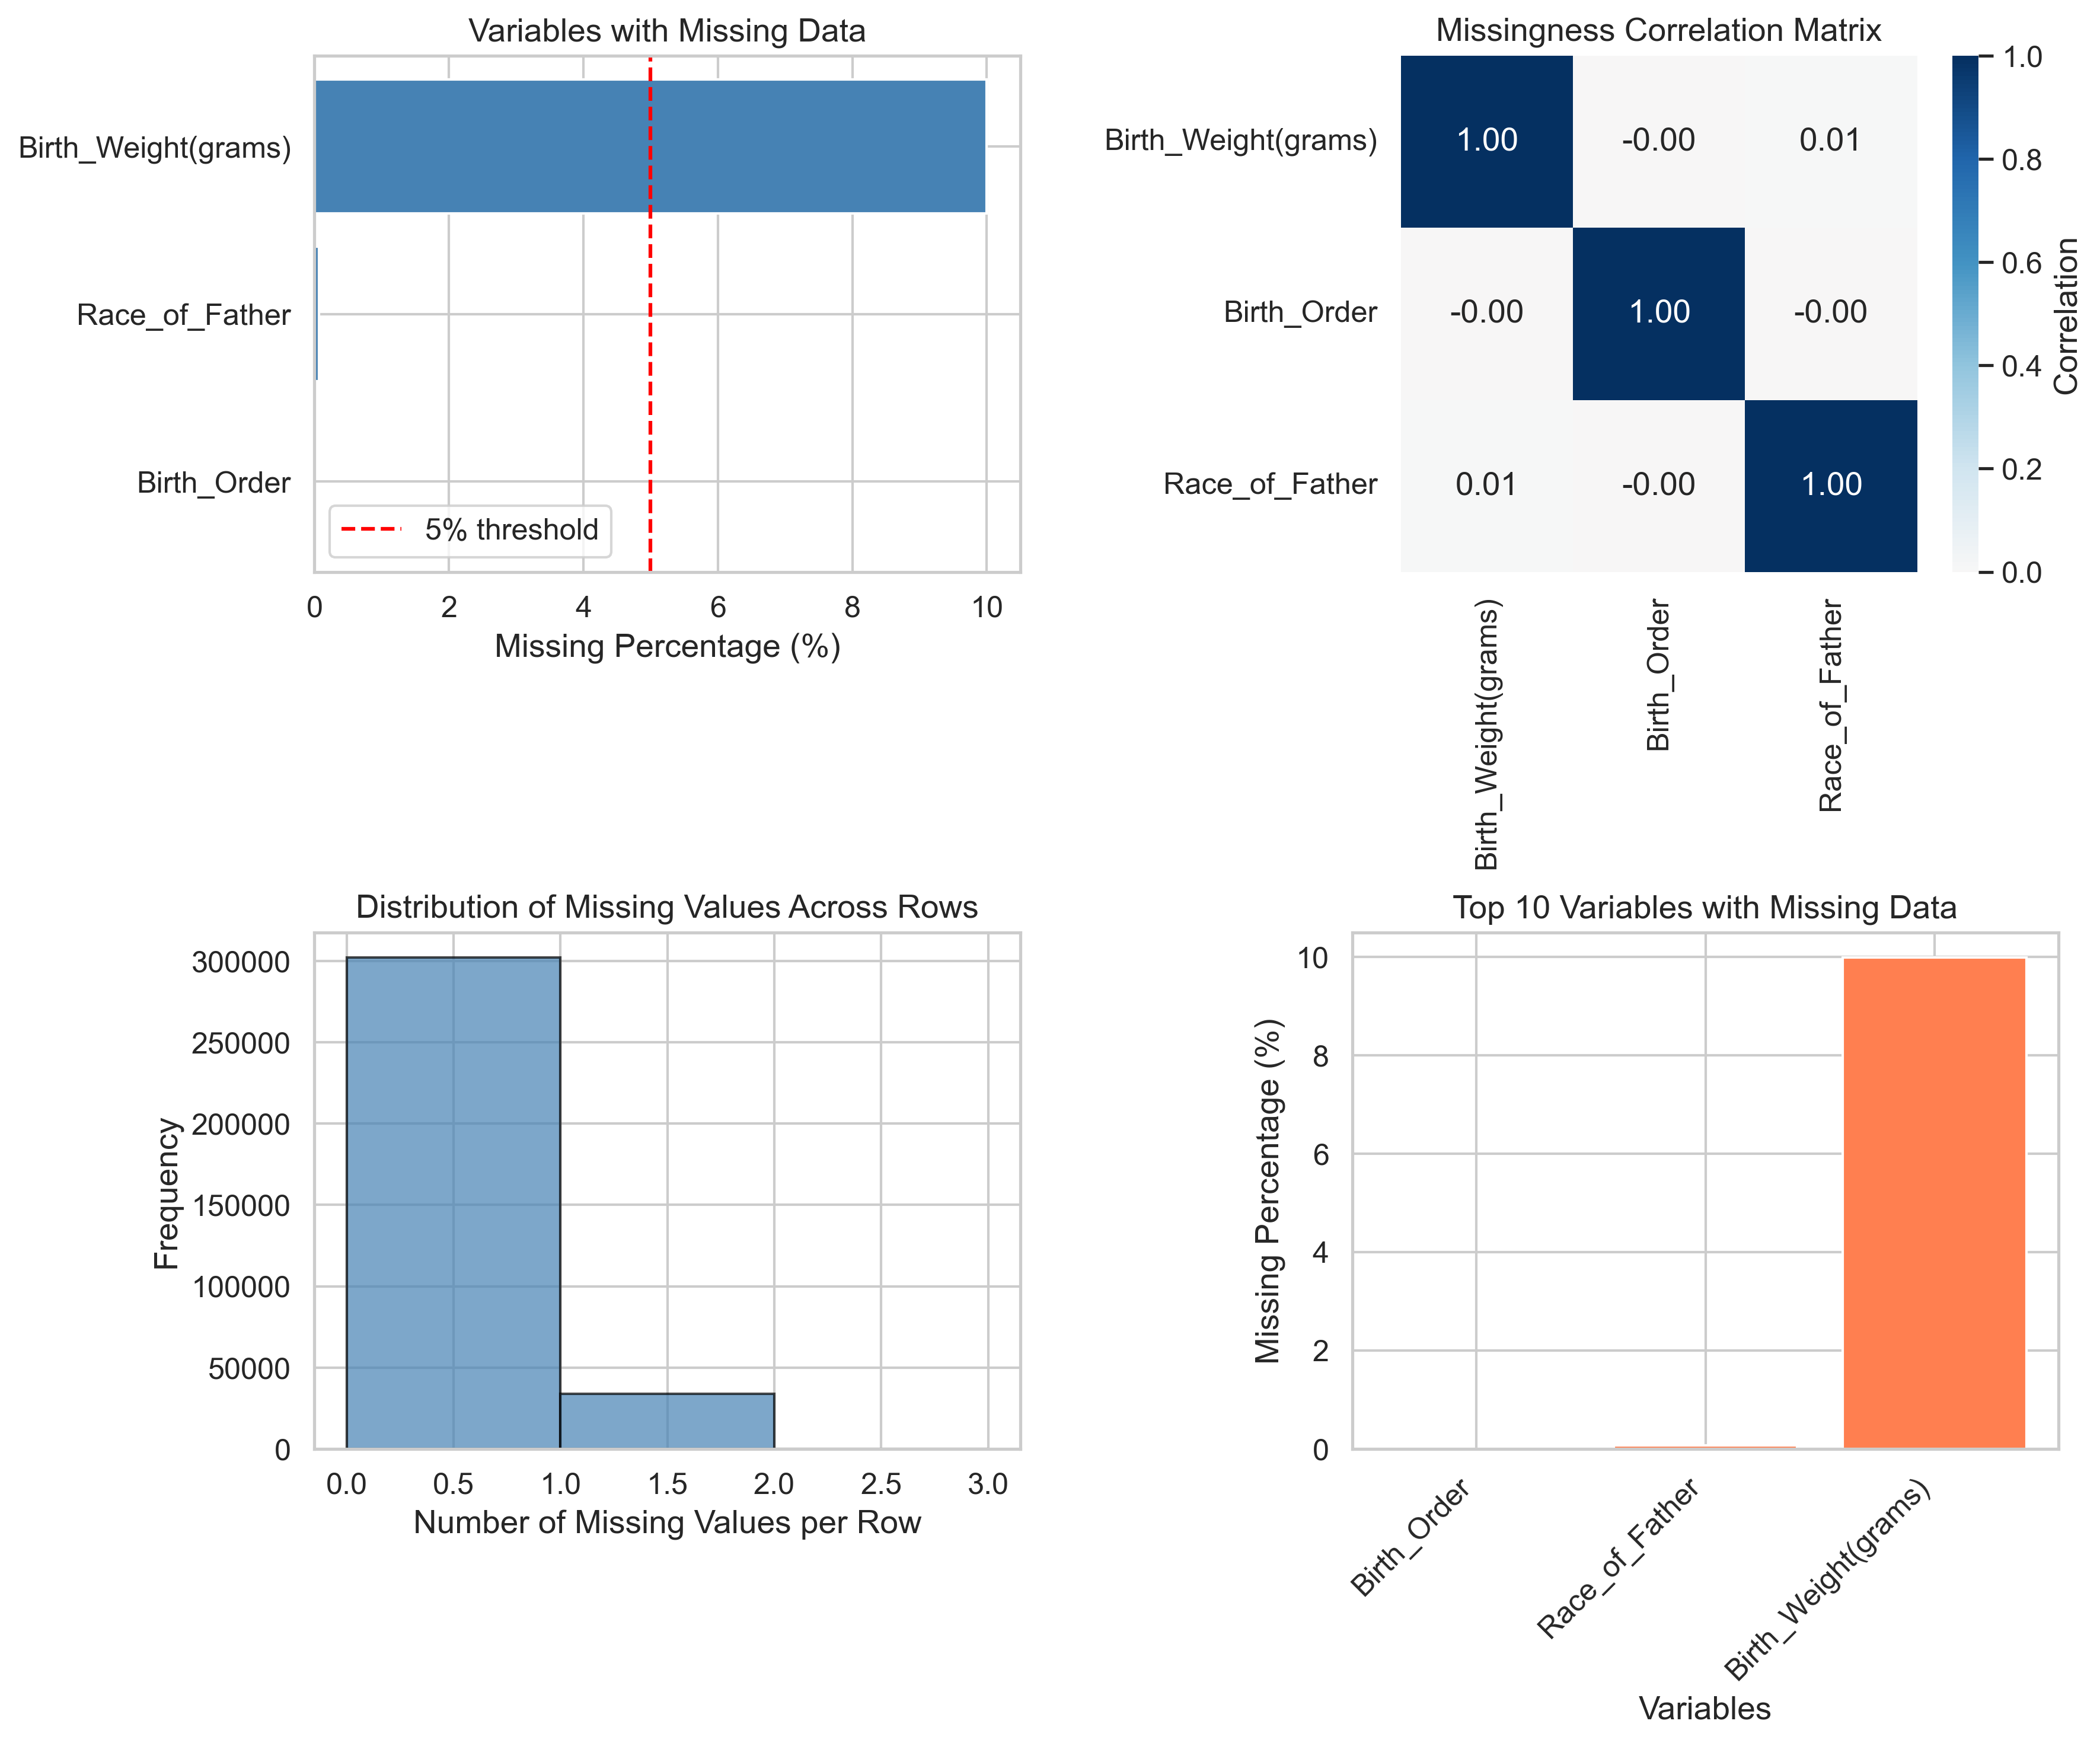
Figure 1: Missing Data Visualizations

6. Recommendations for Missing Data Handling

For MAR Variables:
- Since missingness in these variables depends on observed data, use:
- Multiple Imputation by Chained Equations (MICE)
- Full Information Maximum Likelihood (FIML)
- Expectation-Maximization (EM) Algorithm
Variables to impute: Birth_Weight(grams), Race_of_Father

For Variables without MAR Evidence:
- For these variables, conduct additional tests to determine between MCAR and MNAR:
- Little's MCAR Test - to test for MCAR
- Sensitivity Analysis - to assess MNAR impact
- Pattern-Mixture Models - for MNAR handling

7. Conclusion
Based on the analysis, 2 out of 3 variable(s) with missing data demonstrate MAR patterns. This indicates that missingness is systematically related to observed variables, making multiple imputation an appropriate strategy.
Overall missing data rate is 0.56%, which is low and requires appropriate handling to avoid biased results.

8. Appendix: Detailed Statistics

Complete MAR Results
Variable | MAR Supported | Number of Associations
Birth_Weight(grams) | Yes | 3
Birth_Order | No | 0
Race_of_Father | Yes | 3

